**Numerical Analysis Final Lab**

**Name: Kamil Siddiqui**

**Roll No: ME201024**

**Problem Statement**

Find the roots of the following equation by using appropriate method:

$$x^{3} + 3x - 6 = 0$$

**Code**

|  |
| --- |
| clc, clear all    %y = x^2 + 3*x - 6    f = [1 3 -6];  r = roots(f);    xi = 0;  xf = 3;  n = 15;  xold = 0;    yi = xi^2 + 3*xi - 6;  yf = xf^2 + 3*xf - 6;    fprintf('Iteration root f(x) Error\n')    if yi*yf < 0  for i = 1:n  x3 = (xi+xf)/2;  y3 = x3^2 + 3*x3 - 6;    if y3 == 0;  break  else if yi*y3 < 0  xf = x3;  else if y3*yf < 0  xi = x3;  end  end  end    e = abs((x3-xold)/x3)*100;  xold = x3;    fprintf('%d %.4f %.4f %.2f\n', i, x3, y3, e)    end  else  disp("No roots between the limit")  end    a = -8:.2:5;  b = a.*a + 3*a - 6;    plot(a,b, "r--"); hold on;  scatter(r(1),0)  scatter(x3,0)    xlim([-6 4])  ylim([-10 10])  line([0 0], [-10 35])  line([-8 10], [0 0]) |

**Command Window**

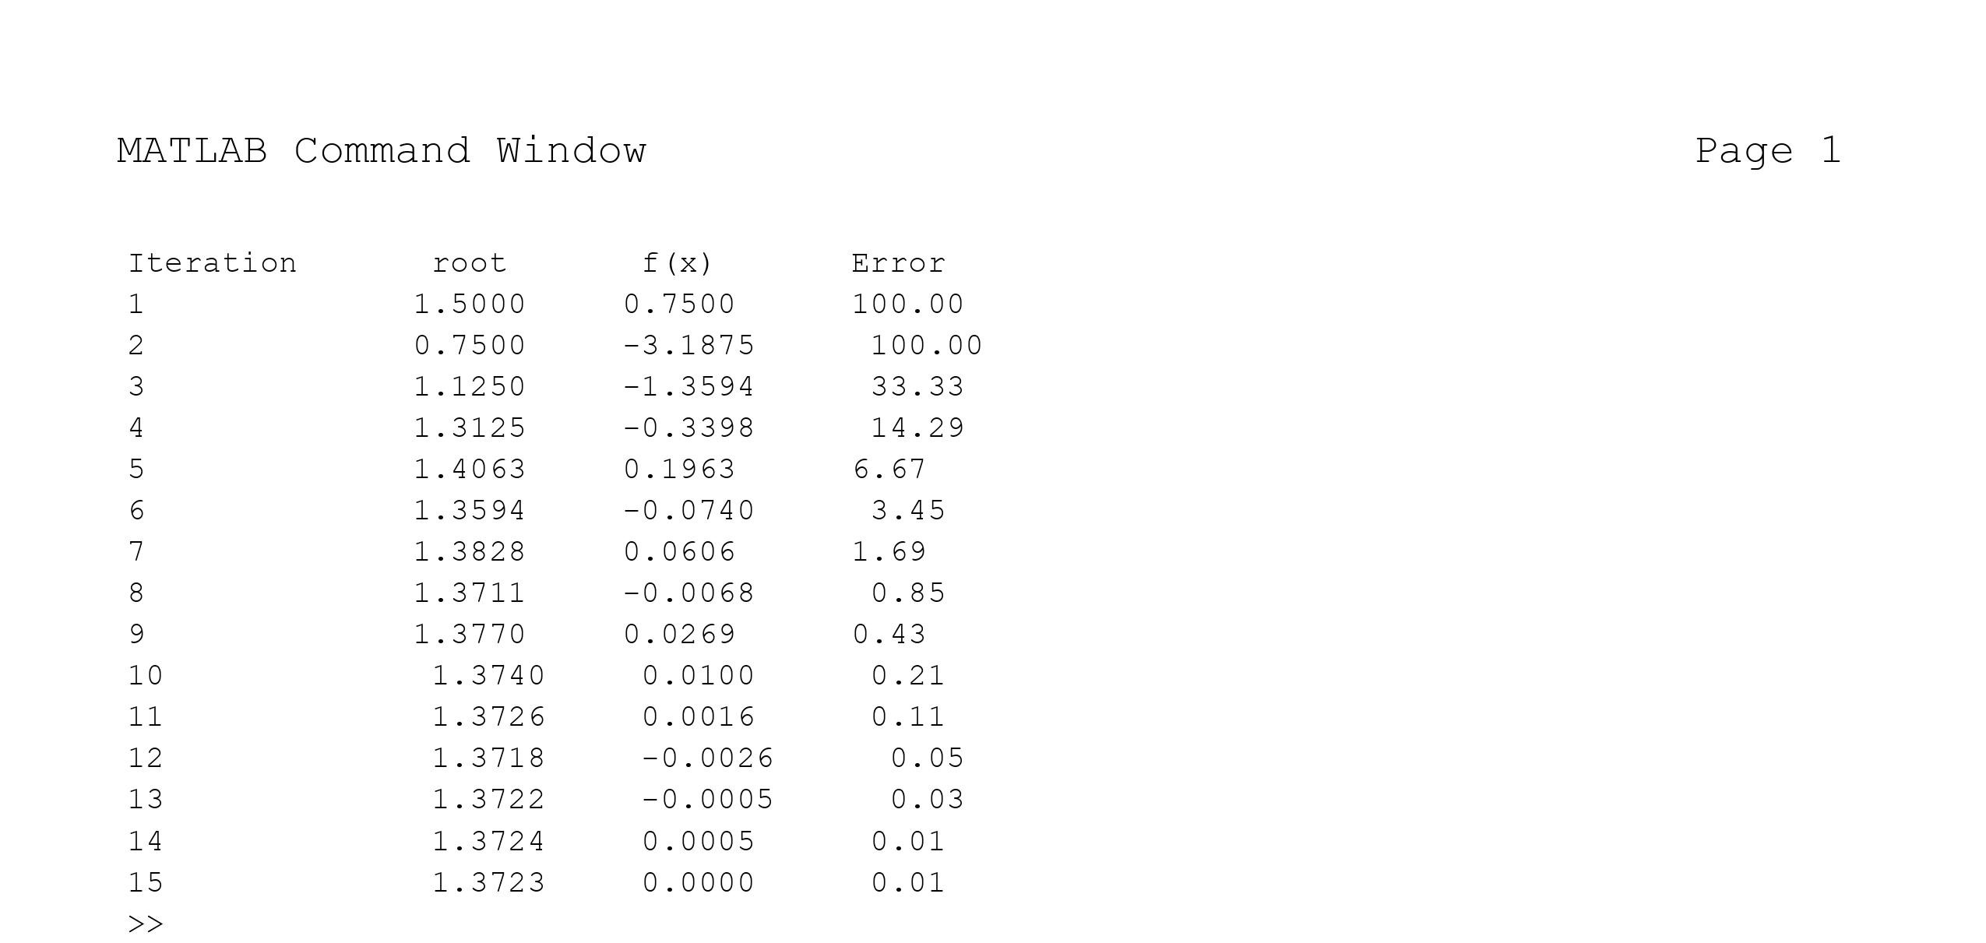

**Graph**

